**COMMONWEALTH INFORMATION TECHNOLOGY SOCIETY**

Academic Year 2020 – 2021

1st Semester

**TABLE OF CONTENTS**

Cover Page 0

Table of Contents 1

Documentation

Information Technology in the New Normal:

Teaching Fundamentals of C Programming 2

Appendices

Appendix 1 Certificate of Accreditation 15

Appendix 2 List of Officers 16

Appendix 3 Constitution and By-Laws 18

Appendix 4 Financial Report 31

Appendix 5 Communication Letters 32

Appendix 6 Minutes of the Meeting 33

Appendix 7 Evaluation 34

**Information Technology in the New Normal:**

**Teaching Fundamentals of C Programming**

January 24, 2021

**Documentation**



Photo The host delivering her introduction

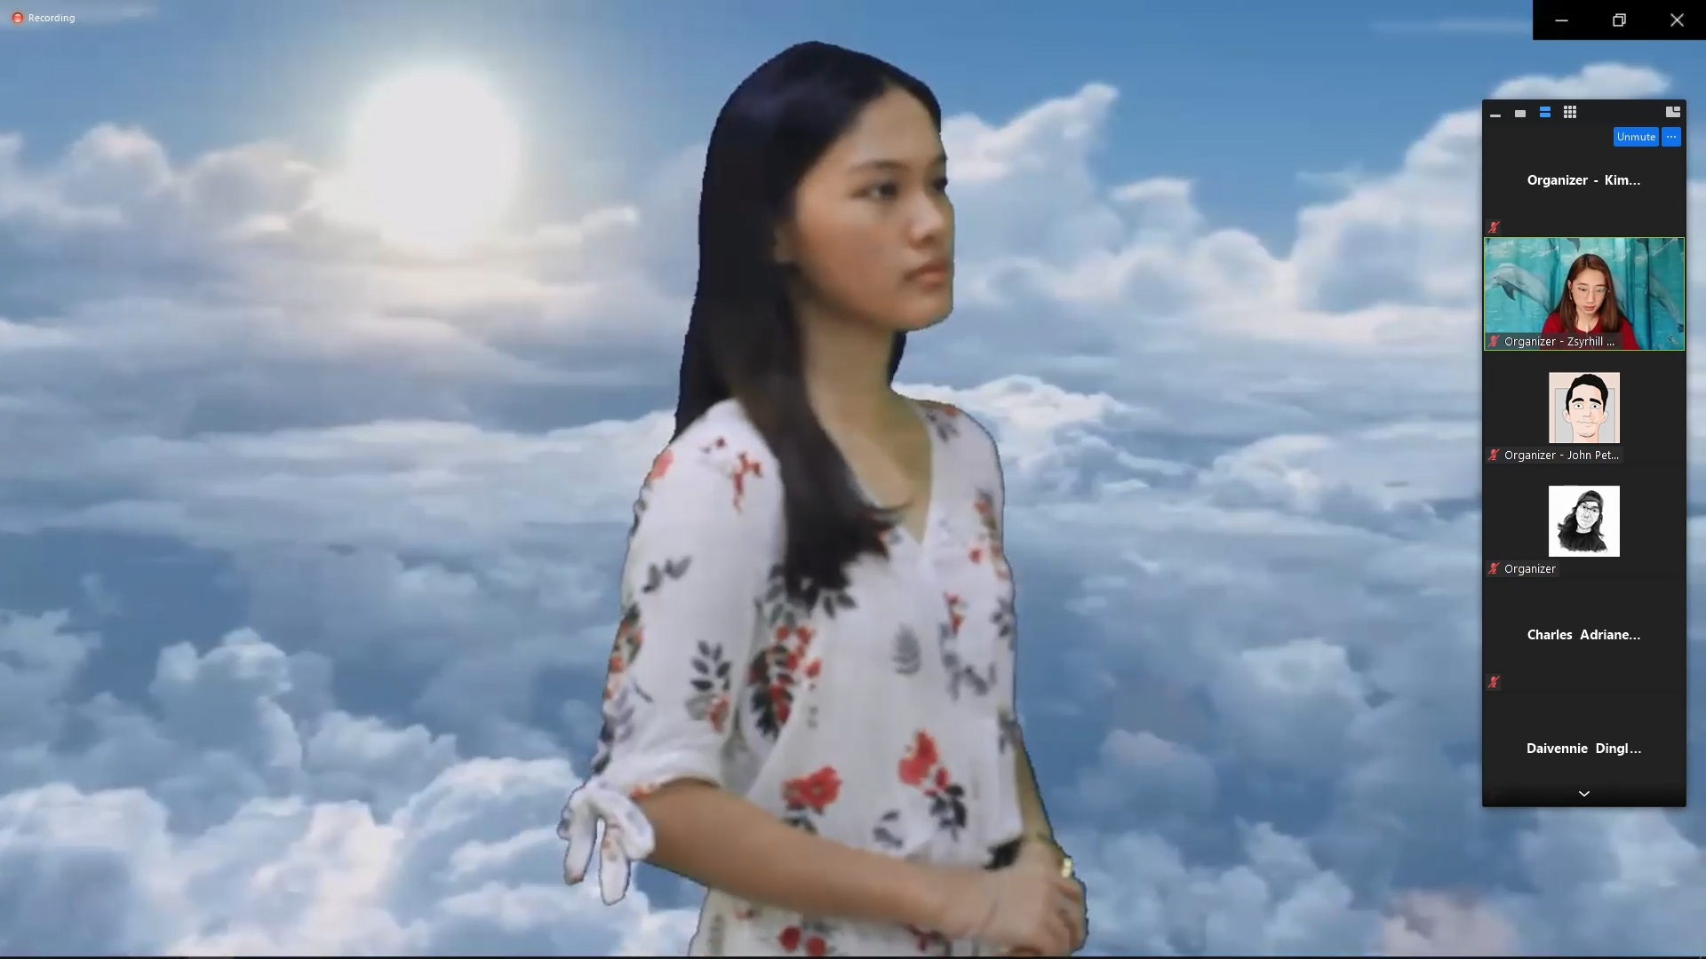

Photo Doxology by Iva Bulawit of BSIT 2-2

*Start of the Program*

*In this new normal, we would like to help our fellow COMMITS members to be inspired and empowered through different activities. In this event that the organization had organized, COMMITS would be giving the participants free lecture regarding C programming.*

*The program was hosted by the organization’s secretary, Zsyrhill Soria from BSIT 2 – 1. It started with the singing of Doxology by Iva Bulawit from BSIT 2 – 2, followed by the singing of the national anthem.*

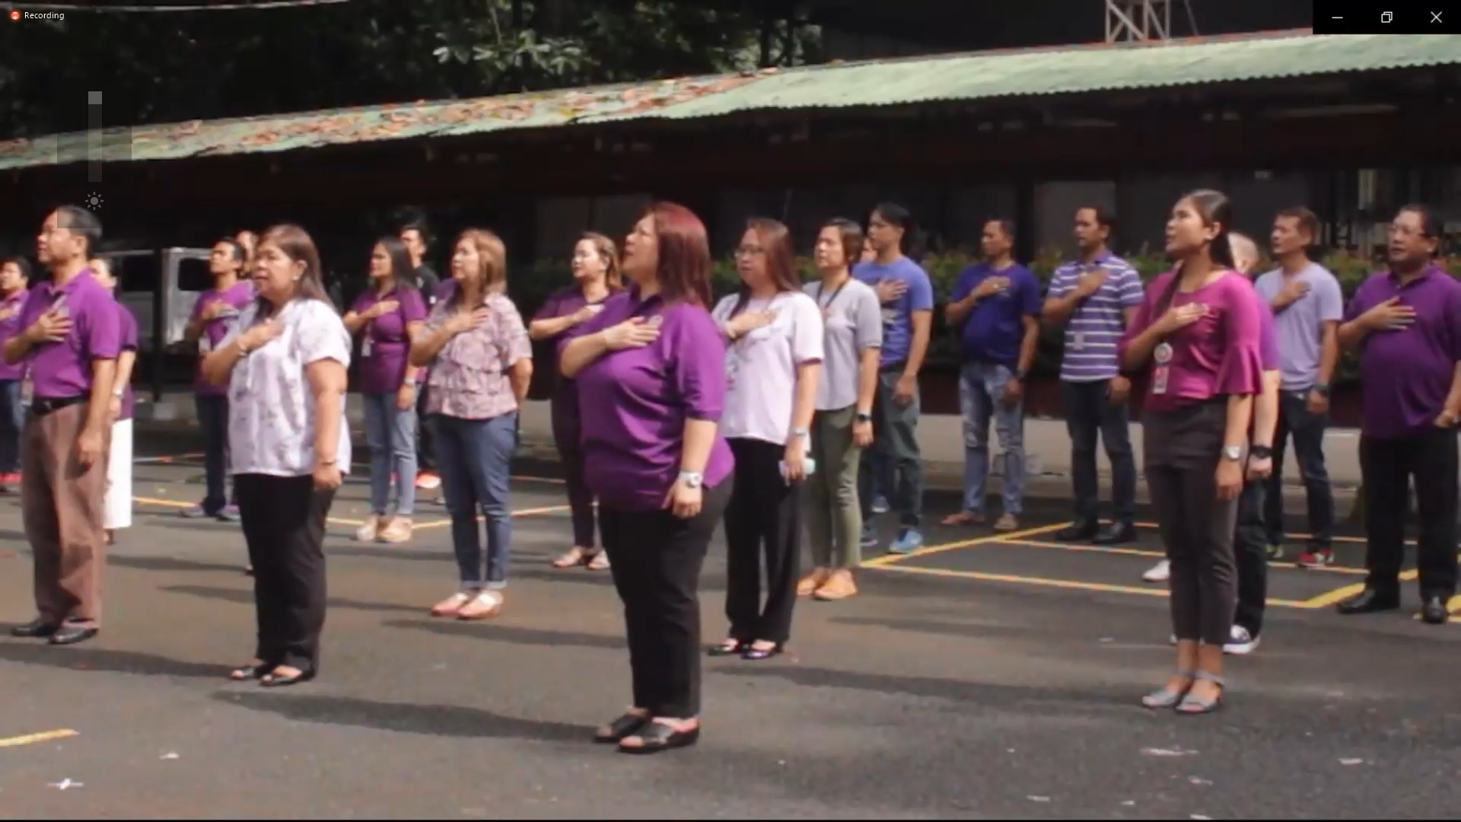

Photo Philippine National Anthem



Photo Introduction of the topic and the Speaker

*Introduction*

*The host introduced the speaker of today’s event from the BSIT 2 – 1, Albert Lupo. The speaker aims to help the participants to understand certain concepts regarding C programming and inspire them to write their codes.*

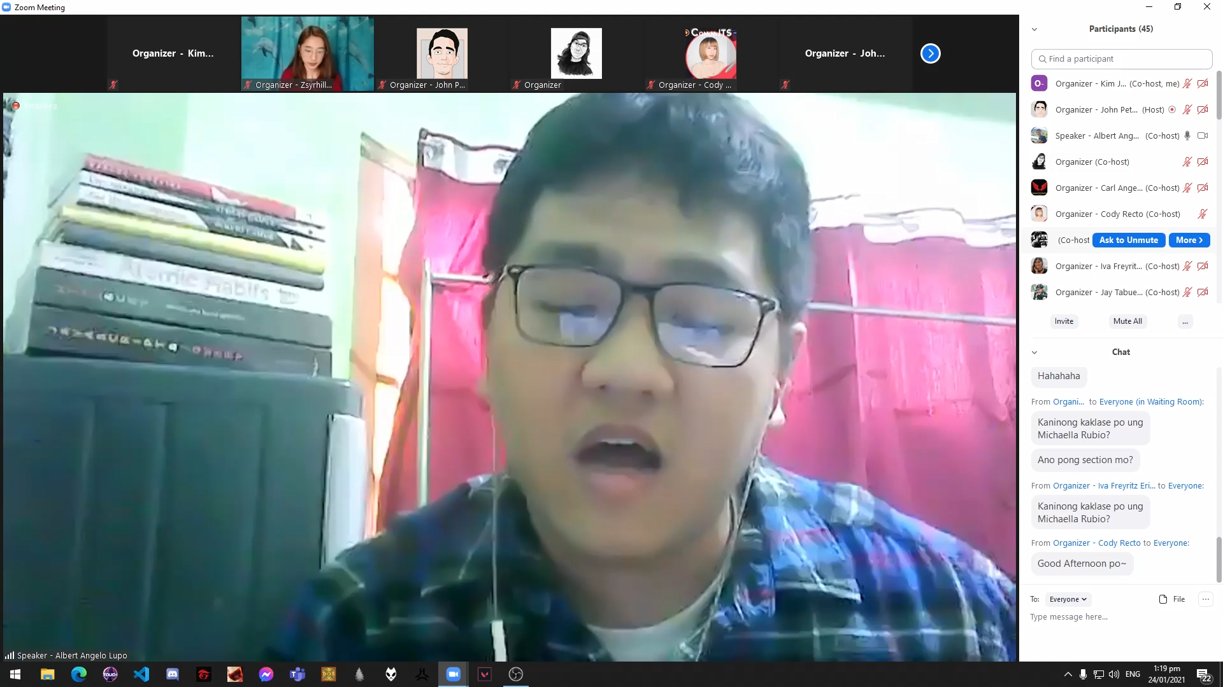

Photo The speaker, Mr. Albert Lupo from BSIIT 2-1

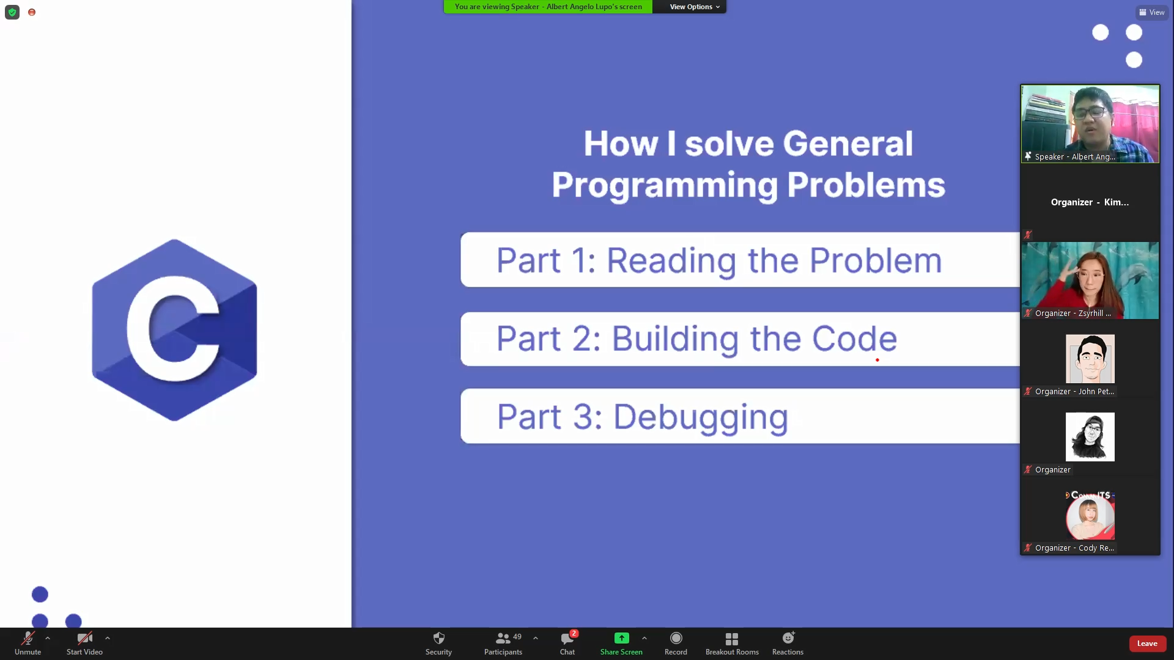

Photo The speaker shows how he solves programming problems

*The 3 Ways to Solve Programming Problems*

*The speaker had summarized his topics into three parts which are: the problem, the code, and the debugging which are all fundamental in programming and C-Programming itself. Because of the target participants which are the freshmen, the speaker had simplified the topic instead to not complicate their understanding of the lesson.*

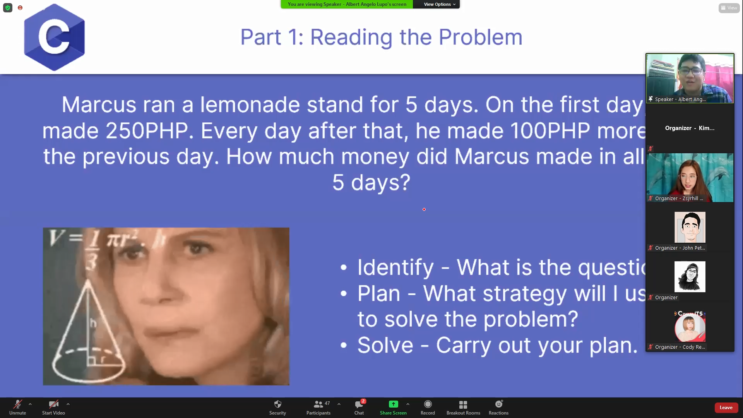

Photo The speaker discusses the first part of the process

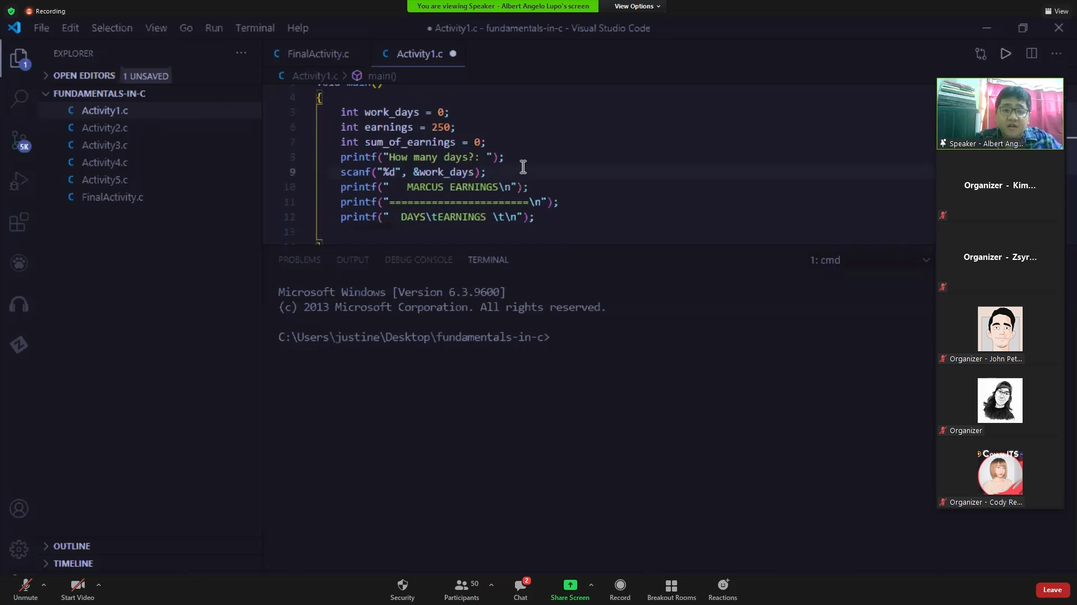

Photo The speaker shows coding examples for the participants

*Live Coding Example*

*The speaker showed the participants examples by coding and captured their interest by the use of memes. The speaker also showed an example of a problem in which he translates into programming problem that would be efficient in coding.*

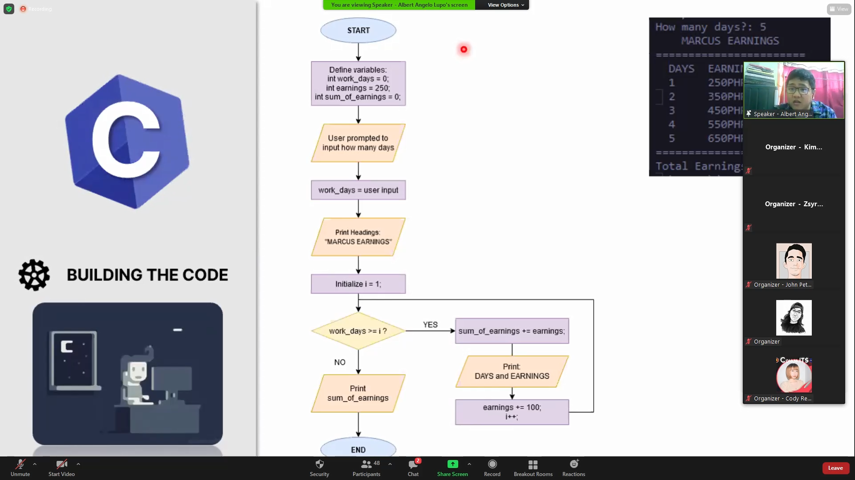

Photo Building the code process

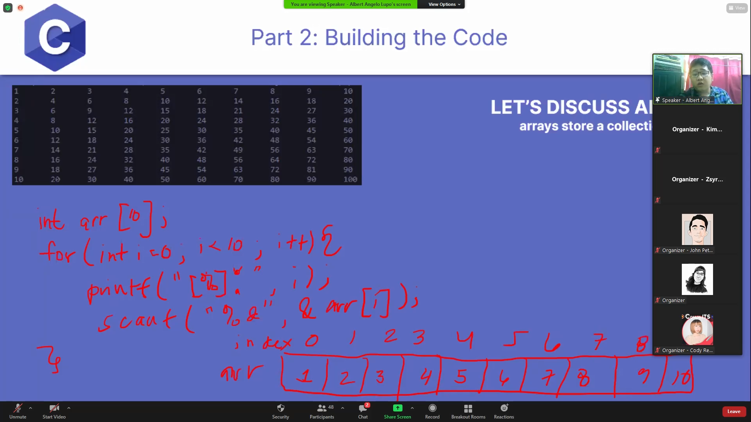

Photo Illustration of arrays

*Flowcharts and Building the Code*

*The speaker moves onto the next process on how to code. He uses a flowchart to tell the participants how the code should work and display the desired output. In the building the code section, the speaker illustrated how arrays work and proceeded to live code the said data structure.*

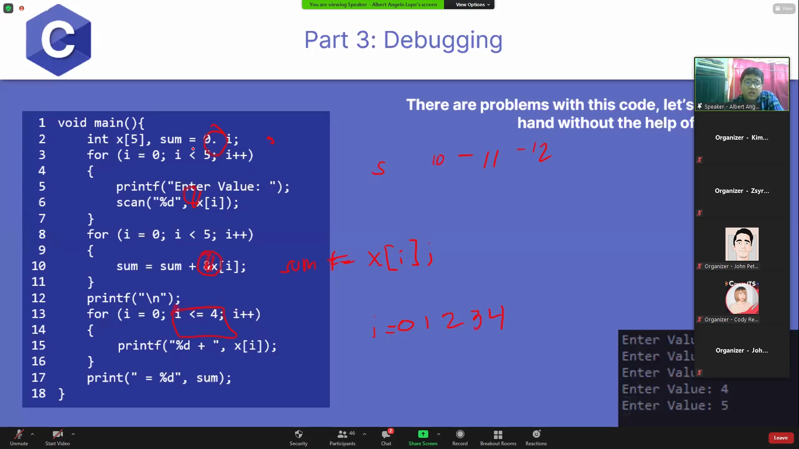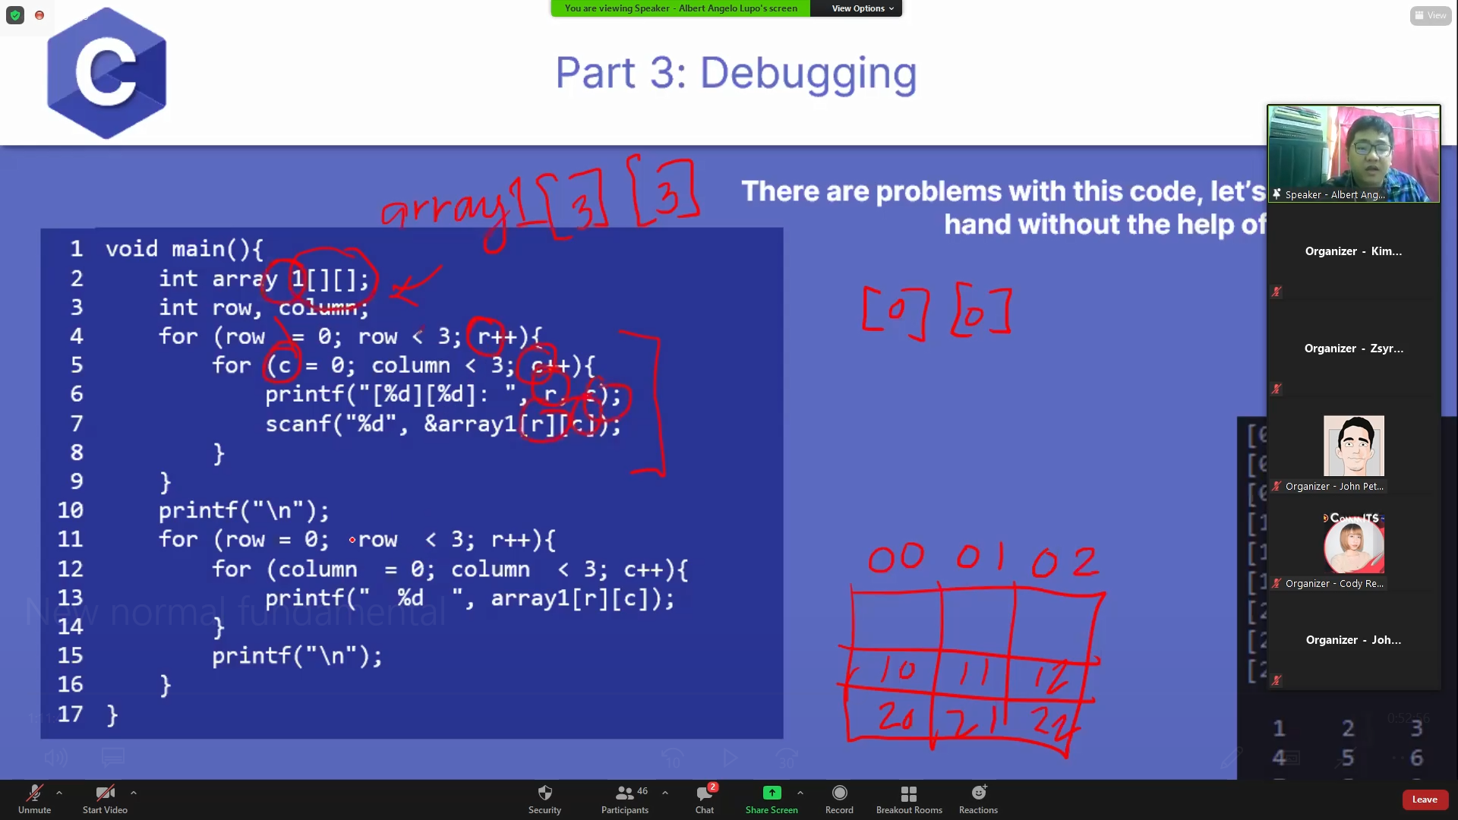

Photo .1 & 11.2 The speakers shows the debugging process

*Debugging*

*The speaker shows them a program with errors and tells the participants how to properly debug their programs. Through the PowerPoint presentation, the speaker showed the various errors in the code and debugs them one by one to ensure that the program would be running efficiently.*

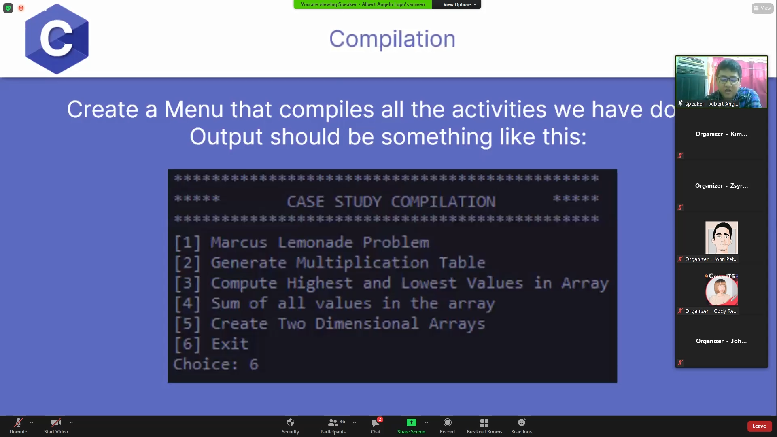

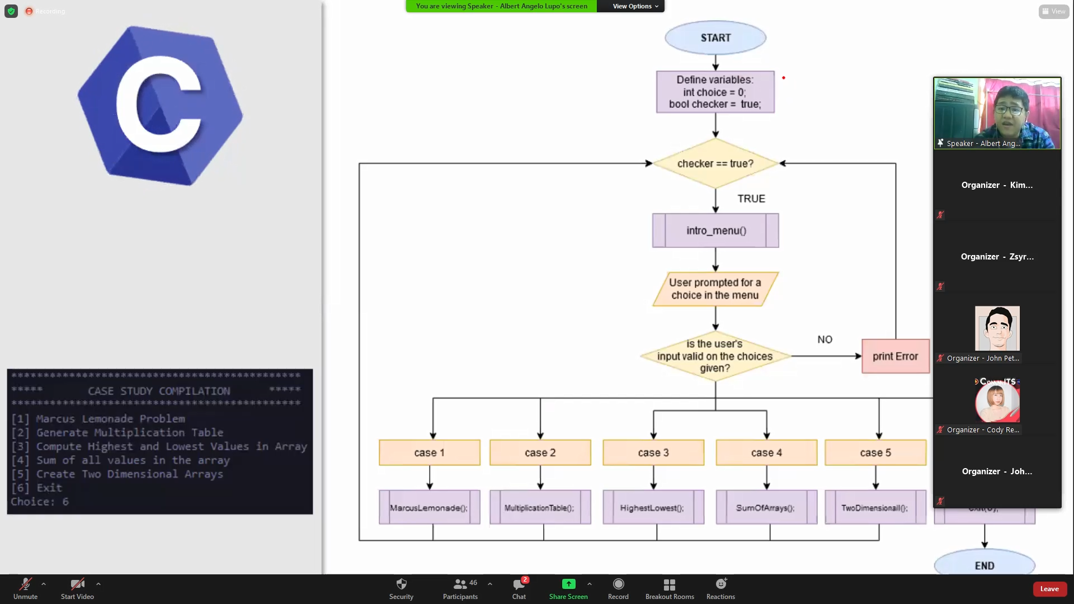

Photo .1 & 12.2 Illustrates how the previous IT students write their case studies

*Case Study*

*The speaker shows how case studies are done and shows an example on how to compile the programs into one case study. Again, the speaker uses a flowchart to show the participants how the program should work and give the user a desired output.*

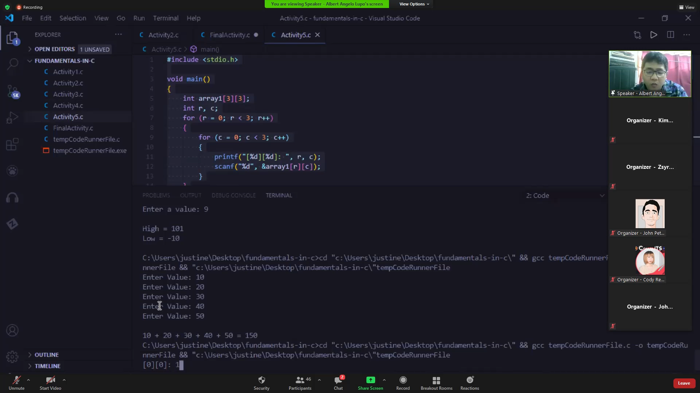

Photo Compilation and execution of the programs

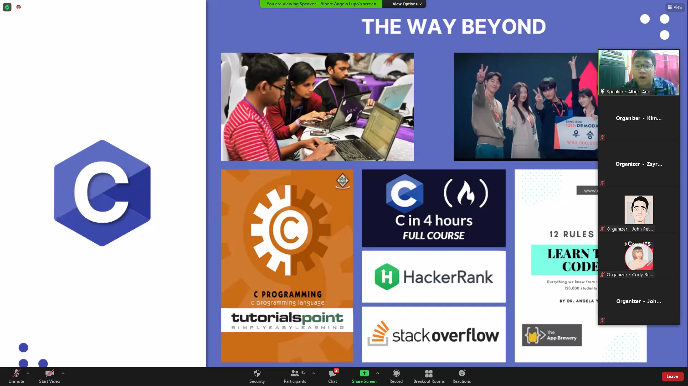

Photo Recommended sites and readings by the speaker to hone the participants' coding skills

*Conclusion*

*Upon the conclusion of the speaker, he compiles and executes the programs previously exampled into one case study. The speaker shows the websites and readings he read that inspired him to code. The speaker highlighted the importance of self-studying the codes, because being a programmer is often self exploratory.*

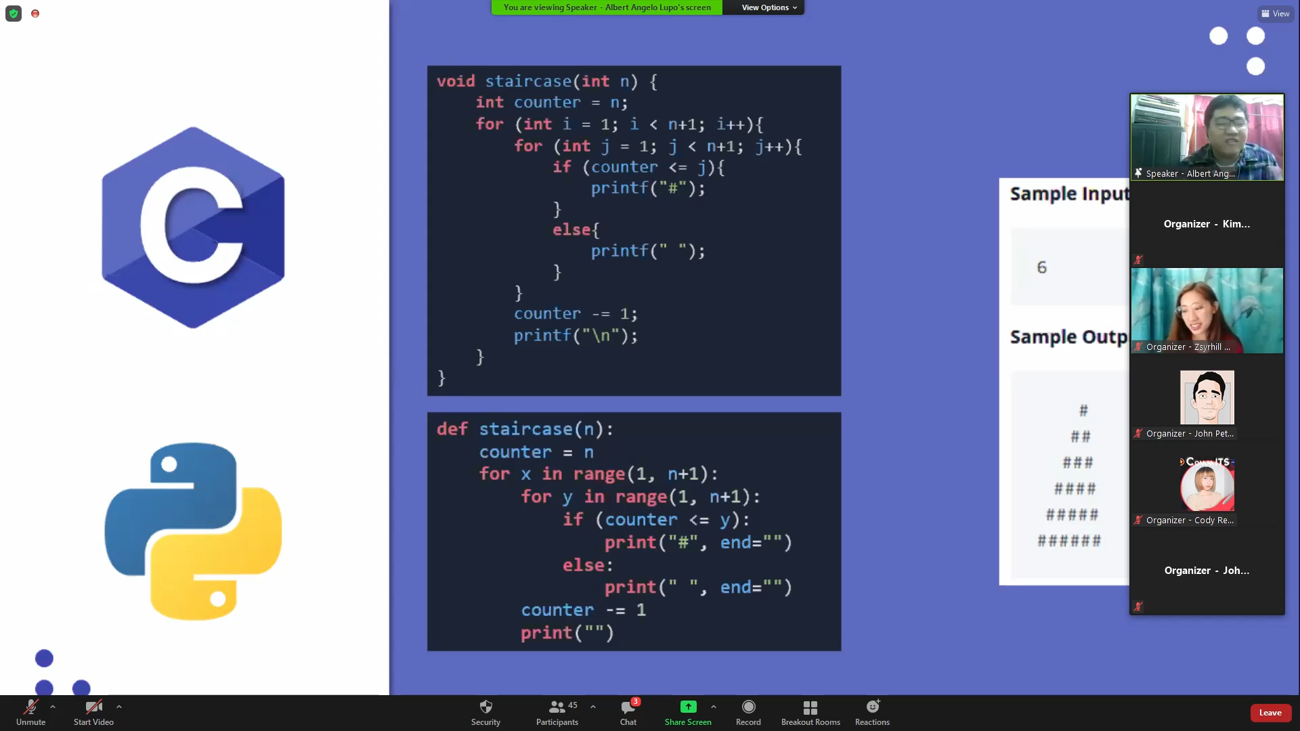

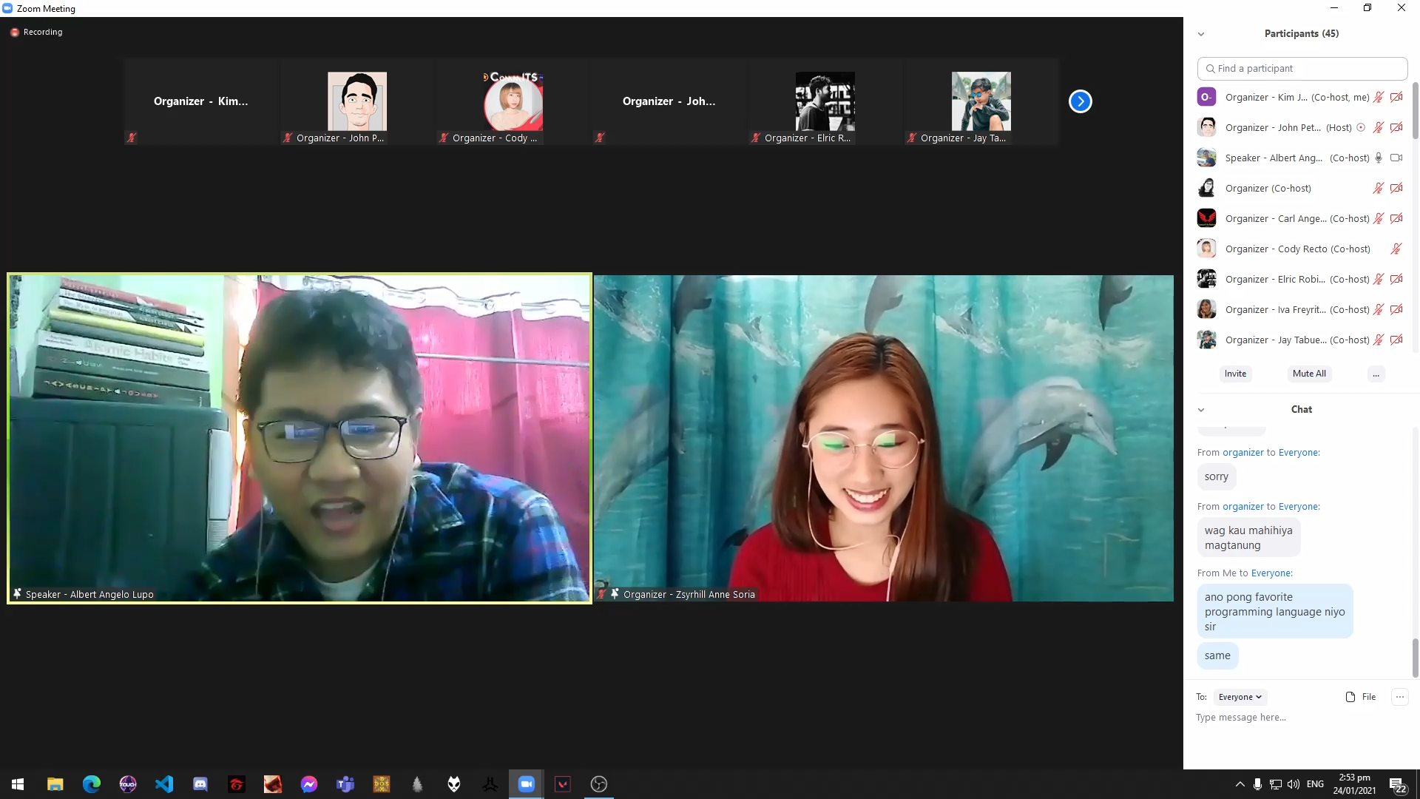

*Question and Answer*

*After the discussion, the speaker entertained programming and non-related questions. The speaker shares his thoughts regarding programming languages, compilers he used for c-programming and others.*

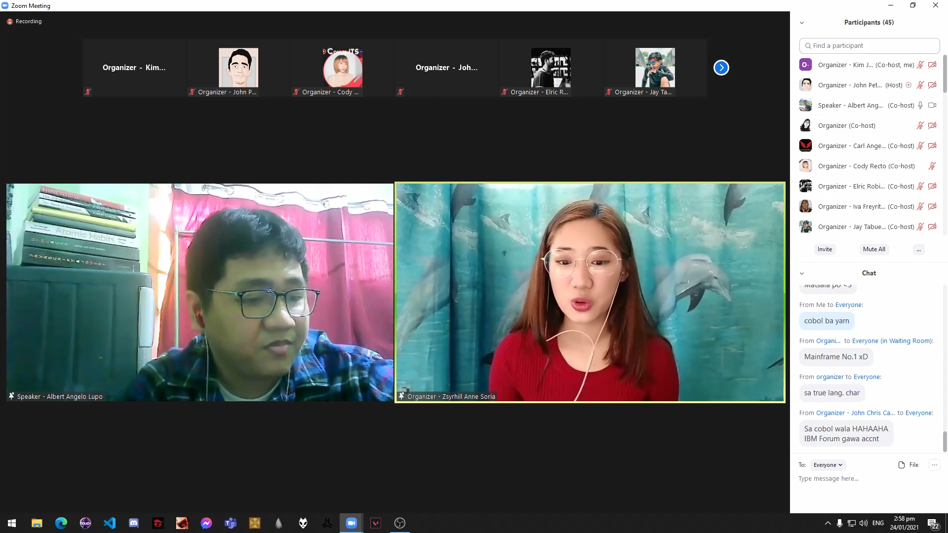

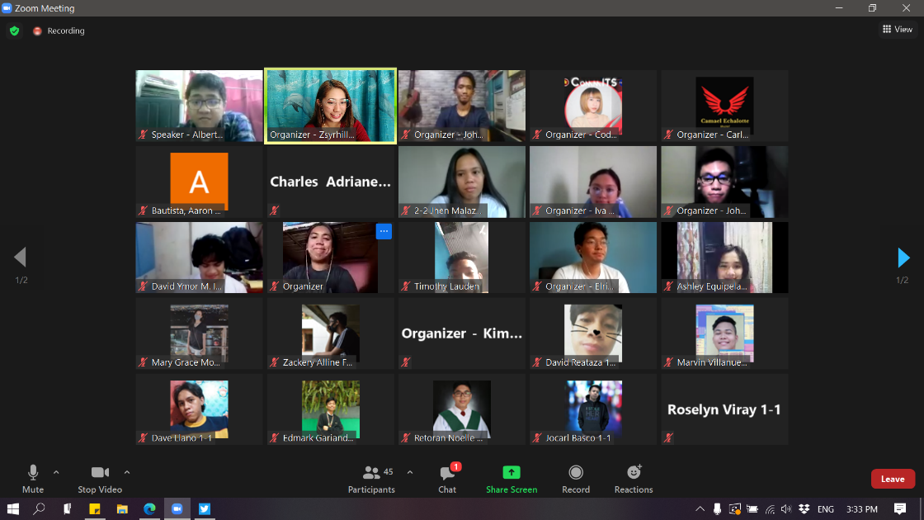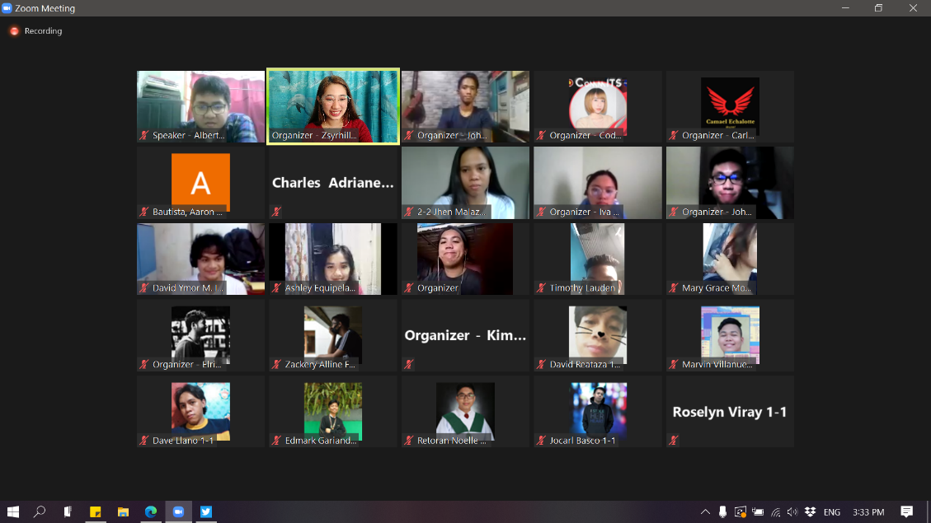

*Closing*

*Upon the closing of the program, the organizers asked questions to the participants which were given rewards. COMMITS President, Mark Kennedy Asilan delivered his closing remarks as the program ended with the PUP hymn and picture taking with participants.*

**Appendices**

**Appendix 1**

Certificate of Accreditation

**Appendix 2**

List of Officers

|  |  |
| --- | --- |
| **COMMONWEALTH INFORMATION TECHNOLOGY**  **LIST OF OFFICERS**  **A.Y. 2020 – 2021** | |
| **NAME** | **POSITION** |
| Mark Kennedy S. Asilan Jr | President |
| Ariel Ordanza Jr. | Vice President for Internal |
| Elric C.J. S. Robillos | Vice President for External |
| John Peter Narzoles | Vice President for Research Development Team |
| Zsyrhill Anne C. Soria | Secretary General |
| Riezel Mae R. Sanchez | Auditor |
| Arlou R. Luganob | Business Manager |
| Angel Ann C. Retamar | PIO |
| Kier A. Esteban | RDT Member |
| Filwayne Kean M. De Lara | RDT Member |
| Jhay Mark T. Pineda | RDT Member |
| Jayson V. Tabuelog | IT 1-1 Representative |
| Cody Grace A. Recto | IT 1-2 Representative |
| Kim John C. Defiesta | IT 2-1 Representative |
| Iva Freyritz Erika Bulawit | IT 2-2 Representative |
| Carl Angelo C. Magbuo | IT 3-1 Representative |
| Angeline T. Balbarino | IT 3-2 Representative |
| Daisy Brillo | IT 4-1 Representative |

**Appendix 3**

Constitution and By-Laws

**CONSTITUTION AND BY-LAWS**

**REVISED 2017**

# **ARTICLE I**

# **NAME, DOMICILE AND LOGO**

## **Section 1.** The official student union of the Bachelor of Science in Information Technology and Diploma in Information Communication Technology Students of Polytechnic University of Philippines, Quezon City Branch shall be known as Commonwealth Information Technology Society.

## **Section 2.** The official domicile of the Commonwealth Information Technology Society shall be at the Commonwealth Information Technology Society Office, Polytechnic University of the Philippines Quezon City Branch, Don Fabian St., Brgy. Commonwealth, Quezon City.

## **Section 3.** The Commonwealth Information Technology Society shall have jurisdiction over the Polytechnic University of the Philippines, Quezon City Branch bonafide Bachelor of Science in Information Technology and Diploma in Information Communication Technology Students.

## **Section 4.** The Commonwealth Information Technology Society reserves the right and authority to use the official logo described below in any official transaction in and off-campus.



The blue arrow stands for a kind of software development process model, the waterfall model. Waterfall model begins with the gathering of requirements, designing and planning the process, implementing the design, verifying the implemented process and maintaining it. It emphasizes the logical progression of the organization. It arrows back to the beginning because every process will start at the requirements and will end up on its maintenance depending on a scenario. Waterfall process is used by the officers in managing the organization.

“CommiT”, which stands for Commonwealth Information Technology, is located at the center of the logo. This symbolizes that both the officers and members should commit themselves to pursue the objectives of the organization.

Invent and Conquer, found under the blue arrow, is the product of the waterfall. Every process has an output, that process and output must overcome, and take control, the organization for the benefit of its members and PUP Quezon City Branch.

# **ARTICLE II**

# **VISION, MISSION, STATEMENT OF OBJECTIVES AND PRINCIPLES**

## **Section 1.** **Vision**

## Quality Information Technology education towards competency among Polytechnic University of the Philippines, Quezon City Branch Students.

## **Section 2. Mission**

## Recognizing the importance of a scientific culture among Bachelor of Science in Information Technology and Diploma in Information Communication Technology Students, the Society shall encourage and promote the advancement of Information Technology.

## **Section 3. Statement of Objectives**

## The Society shall have the following objectives:

### 1.1 Promote Research and Development in Information Technology.

### 1.2 Contribute in the improvement of Information Technology Education.

### 1.3 Promote the exchange of knowledge in Information Technology Education.

### 1.4 Advocate for university progressive policies and programs that affect the Information Technology Sector.

### 1.5 To promote healthy exchange of ideas and constructive criticisms in the form of forum, symposia, consultative discussions in the advancement of the members.

### 1.6 Establish linkages with other organization in the pursuit of common goals and;

### 1.7 To foster strong and harmonious relationship among all members of the Society and the University

**Section 4. Principles**

Everyone requires a guide who must be compassionate to his/her weakness.

# **ARTICLE III**

# **MEMBERSHIP**

## **Section 1.** All bonafide Bachelor of Science in Information Technology and Diploma in Information Communication Technology Students of Polytechnic University of the Philippines Quezon City Branch are automatically member of the Commonwealth Information Technology Society.

# **ARTICLE IV**

# **DUTIES AND RESPONSIBILITIES OF MEMBERS**

## **Section 1.** It shall be the duty and responsibility of the member to:

### 1.1 Observe always the laws of the land, the rules and regulation of the University, the Supreme Student Council and the Commonwealth Information Technology Society.

### 1.2 Help promote an atmosphere conductive for peace and harmony among various sectors of the university.

### 1.3 Exercise their rights and responsibilities with due regard for the right of their fellow students and other members of the Polytechnic University of the Philippines, Quezon City Community.

### 1.4 Be responsible in carrying out the objectives of the Society, protecting its good name, maintaining a high degree of scientific standards, and abiding by the principles of ethics.

### 1.5 Pay Membership Fee levied by the Society.

# 

# **ARTICLE V**

# **BILL OF RIGHTS**

## **Section 1.** It shall be the right of the member to:

### 1.1 Know and be informed of the matters affecting them.

### 1.2 Exercise suffrage or right to vote and hold elective or appointive positions in the Society.

### 1.3 Represent the Society in and outside the campus.

### 1.4 Enjoy freedom of speech and of the press.

### 1.5 Undertake research, publish and discuss findings and recommendations relating to academic and non-academic endeavors in accordance with the principles of academic freedom.

### 1.6 Appeal decisions affecting their rights, interests and welfare.

### 1.7 Not be subjected to exploitation, harassment (in words and in deeds), and cruel and/or unusual punishment.

# **ARTICLE VI**

# **THE COMMONWEALTH INFORMATION TECHNOLOGY SOCIETY**

## **Section 1.** The Commonwealth Information Technology is an Academic Organization that always towards the development of students’ personal relationships and encouraging them to participate in group activities especially in academic competitions.

## **Section 2.** The Commonwealth Information Technology Society shall compose of the President, Vice President for Research and Development, Vice President for Internal Affairs, Vice President for External Affairs, Secretary General, Budget and Finance Officer, Associate Budget and Finance Officer, Auditor, Business Manager, Public Affairs Officer and four Research and Development Commissioners all elected at large by the Polytechnic University of The Philippines, Quezon City Branch Bachelor of Science in Information Technology and Diploma in Information Communication Technology Students.

## **Section 3.** The Commonwealth Information Technology Society President shall exercise authority over his/her cabinet.

## **Section 4.** The Commonwealth Information Technology Society have the power to legislate, implement, approve and disapprove rules & regulations, policies and resolutions, programs and projects concerning its members.

## **Section 5.** All decisions/resolutions made and passed by the Commonwealth Information Technology Society shall be approved by the required quorum and shall take effect after the required number of quorum voted as provided in other article and sections of this Constitution.

## **Section 6.** The Commonwealth Information Technology Society shall be responsible for all its actions, decisions, programs, projects, activities and all other important matters concerning its members.

# **ARTICLE VII**

# **DUTIES AND RESPONSIBILITIES OF THE COMMONWEALTH INFORMATION TECHNOLOGY SOCIETY OFFICERS**

## **Section 1.** The **President** shall have the following power, duties and responsibilities:

### 1.1 The President is the Chief Executive Officer of the Commonwealth Information Technology Society and s/he shall represent the Commonwealth Information Technology Society in all its official transactions.

### 1.2 Shall exercise over-all supervision and responsibility over the Society.

### 1.3 Shall determine the guidelines for policy-making and implementation.

### 1.4 Shall build up the integrity, strengthen camaraderie among its officers, and advance the interest, rights and welfare of the members.

### 1.5 Shall sign all communication letters, resolutions, memorandums and documents of the Society for official transaction.

### 1.6 Shall ensure the validity of any rule, regulation, resolution, memorandum, program, and special project of the Organization in accordance with existing rules and regulations of the Society, Council and the University.

### 1.7 Shall maintain the issuance of legal documents.

### 1.8 Shall handle the complaints and grievances of members and shall take and provide appropriate actions and solutions.

### 1.9 Shall enforce the provisions of this Constitution and all other rules and regulations that may be promulgated from time to time.

### 1.10 Shall have the sole jurisdiction to create positions, committees and special bureaus within the society as may be deemed appropriate and necessary.

1.11 Shall be part of the Council of Leaders Technical Working Committee – Legality, Peace and Conflict Resolution Committee and shall follow all the tasks given by the chairperson of the committee.

**Section 2.** The **Vice President for Research and Development** shall have the following power, duties and responsibilities:

* 1. Shall supervised the Research and Development Team.
  2. Shall provide and maintain the demographic record of all members of the Society.
  3. Shall be responsible in making accomplishment reports, evaluations and documentation of each activities/events of the Society.
  4. Shall be responsible in making the annual action research
     1. The said research must address the needs of the members that can provide by the society.
  5. Shall supervise the annual Extension Project of the University through the Society.
     1. Shall conduct a survey to partnered barangay personnel to identify their needs that can be conducted as an Extension Project.
     2. Shall serve as the bridge between Barangay and University Administration related to the Extension.
     3. Shall conduct an evaluation to the barangay personnel regarding the extension provided to them by the University.
  6. Shall be responsible in gathering feedback and suggestions of the members after an activity, event, workshop, training and seminar
  7. Shall perform other duties delegated by the President
  8. Shall seek the approval of the President in all matters concerning his/her duties and responsibilities.
  9. Shall be part of the Council of Leaders Technical Working Committee – Research Groups and Teams Committee and shall follow all the tasks given by the chairperson of the committee.

**Section 3.** The **Vice President for Internal Affairs** shall have the following power, duties and responsibilities:

* 1. Shall assume the Office in case of the latter’s absence, incapacity or resignation of the President.
  2. Shall serve as the bridge of the organization to the University Administration.
  3. Shall have the responsibility for the procurement of supplies needed by the organization.
  4. Shall be responsible for the records of all supplies, equipment and furniture of the organization.
  5. Shall ensure the rules, regulation, resolution memorandum, programs, special project and others that concern the organization.
  6. Shall report all in-campus concerns relating to the implementation of programs, projects, and activities of the organization.
  7. Shall maintain records of legal documents in the organization.
  8. Shall ensure the functioning of all officers in the organization by proper orientation and supervision.
  9. Shall perform other duties delegated by the President.
  10. Shall seek the approval of the President in all matters concerning his/her duties and responsibilities.
  11. Shall be part of the Council of Leaders Technical Working Committee – Internal Programs, Projects and Activities Committee and shall follow all the tasks given by the chairperson of the committee.

**Section 4.** The **Vice President for External Affairs** shall have the following power, duties and responsibilities:

* 1. Shall serve as the bridge of the organization to the sponsors, speakers and other stakeholders outside campus.
  2. Shall provide and keep track of the directory of sponsors for events, seminars, projects and activities.
  3. Shall report all out-campus concerns relating to the implementation of programs, projects, and activities of the organization.
  4. Shall perform other duties delegated by the President.
  5. Shall seek the approval of the President in all matters concerning his/her duties and responsibilities.
  6. Shall be part of the Council of Leaders Technical Working Committee – External Programs, Projects and Activities Committee and shall follow all the tasks given by the chairperson of the committee

**Section 5.** The **Secretary General** shall have the following power, duties and responsibilities:

* 1. Shall control all publications of the Commonwealth Information Technology Society.
  2. Shall sign all communication letters, resolutions, memorandums and documents of the Society for official transaction.
  3. Shall record and keep the minutes of the meeting and circulars relating on the implementation of plans, programs, projects and activities of the organization.
  4. Shall perform other duties delegated by the President.
  5. Shall seek the approval of the President in all matters concerning his/her duties and responsibilities.

**Section 6.** The **Budget and Finance Officer** shall have the following power, duties and responsibilities:

* 1. With the President shall be the only co-signatory of any check or withdrawal slip drawn against the bank account of the Society.
  2. Shall be the Bookkeeper and Fund Administrator of the Society.
  3. Shall record and keep control of the utilization of funds of the Society.
  4. Shall maintain the proper documentation of cash receipts and disbursements of the Society.
  5. Shall serve as the Treasurer of the Organization.

### Shall provide and submit periodic, per project and activity financial report to the Council, the Student Affairs and to the Adviser for record-keeping and perusal.

### Shall perform other duties delegated by the President.

### Shall seek the approval of the President in all matters concerning his/her duties and responsibilities.

### Shall be part of the Council of Leaders Technical Working Committee – Business, Budget and Finance Committee Budget Division and shall follow all the tasks given by the chairperson of the committee.

**Section 7.** The **Auditor** shall have the following power, duties and responsibilities:

* 1. Shall check and countercheck the accounts and expenditures of the Society.
  2. Shall verify and audit the financial reports of the Budget and Finance Officer.
  3. In partnership with Internal Affairs regarding the inventory of materials, equipment and furniture of the organization. The auditor shall make an inventory of the Society’s assets.
  4. Shall report financial discrepancies concerning the Society to the President.
  5. Shall perform other duties delegated by the President.
  6. Shall seek the approval of the President in all matters concerning his/her duties and responsibilities.
  7. Shall be part of the Council of Leaders Technical Working Committee – Business, Budget and Finance Committee Audit Division and shall follow all the tasks given by the chairperson of the committee.

**Section 8.** The **Business Manager** shall have the following power, duties and responsibilities:

* 1. Shall be responsible for all fund-raising and income-generating projects and activities of the Society.
  2. Shall check the validation of receipts issued by the Society.
  3. Shall be responsible in coordinating and organizing special projects.
  4. Shall perform other duties delegated by the President.
  5. Shall seek the approval of the President in all matters concerning his/her duties and responsibilities.
  6. Shall be part of the Council of Leaders Technical Working Committee – Business, Budget and Finance Committee Business Division and shall follow all the tasks given by the chairperson of the committee

**Section 9.** The **Public Affairs Officer** shall have the following power, duties and responsibilities:

* 1. Shall coordinate and disseminate information, announcements and advisories between and among the Officers and the Members.
  2. Shall keep the minutes of the meeting and circulars relating on the implementation of plans, programs, projects and activities of the organization for transparency.
  3. Shall perform other duties delegated by the President.
  4. Shall seek the approval of the President in all matters concerning his/her duties and responsibilities.
  5. Shall be part of the Council of Leaders Technical Working Committee – Public Information and Communication Committee and shall follow all the tasks given by the chairperson of the committee

**Section 10.** The **Research and Development Officers** shall have the following power, duties and responsibilities:

* 1. The Research and Development Team shall be composed of the Vice President for Research and Development and four Officers.
  2. Shall assist the Vice President for Research and Development in all matters concerning the team.
  3. Shall perform other duties delegated by the President
  4. Shall seek the approval of the President in all matters concerning his/her duties and responsibilities.
  5. Shall be part of the Council of Leaders Technical Working Committee – Research Groups and Teams Committee and shall follow all the tasks given by the chairperson of the committee.

**Section 11.** The **Class Representative** shall have the following power, duties and responsibilities:

* 1. All Class Presidents are automatically the Class Representative.
  2. The Class President is the Chief Executive Officer of their respective class and s/he shall represent their class in the Society.
  3. Shall exercise over-all supervision and responsibility over their class.
  4. Shall coordinate and disseminate information to their section with proper supervision of the organization.
  5. Shall report all class concerns relating to the implementation of programs, projects, and activities of the Society and the University
  6. Shall ensure the functioning of all class officers by proper orientation and supervision.
  7. The Vice President of the Class shall assume the position in case of the latter’s absence, incapacity or resignation of the Class President.
  8. Shall perform other duties delegated by the President.
  9. Shall seek the approval of the President in all matters concerning his/her duties and responsibilities.
  10. As a Class President, a Class Representative shall be part of the Council of Leaders Technical Working Committee – Legality, Peace and Conflict Resolution Committee and shall follow all the tasks given by the chairperson of the committee.

**ARTICLE VIII**

**ELECTION OF THE OFFICERS**

**Section 1.** The Commission on Election of CommITS has the sole jurisdiction in facilitating the CommITS officers’ election. At the last General Assembly, the outgoing officers will introduce the new set of officers. The outgoing officers will turnover their respective position to the new set of officers and will have the oath of office.

**Section 2.** The member of the organization shall elect from among the candidates the President, Vice President for Research and Development, Vice President for Internal Affairs, Vice President for External Affairs, General Secretary, Budget and Finance Officer, Auditor, Business Manager, Public Affairs Officer and; Research and Development Officers.

**Section 3.** The Candidates must have the following qualification for validation:

* 1. He/she must be a bonafide member of CommITS and currently enrolled in the current semester.
  2. Only 3rd or 4th year student can be a candidate for presidency.

**Section 4.** All Outgoing Officers shall act as the Commissioners for the Election.

* 1. The Commission on Election shall provide the following services:
     1. To supervise and conduct the election, perform its duties in accordance with established election practices, carry and certify in writing the returns to the presiding officer.
     2. To recommend to the students’ effective measures to minimize all forms of election frauds and malpractice.
     3. To register and accredit political parties in accordance with the laws.
     4. To pass judgment on election protests concerning election returns and qualifications of candidates for elected position.
     5. To report the results of elections to the members and the entire organization.
  2. If an outgoing officer will run in any position for that election, he/she shall be excluded from facilitating the election.

**Section 5.** The Commission on Election has the sole jurisdiction in setting the timeframe of election.

**Section 6.** The outgoing President will act as the Commission on Elections Chairperson of the Society. He/she shall have the sole jurisdiction to create positions, committees and special bureaus within the commission as may be deemed appropriate and necessary.

**Section 7.** All decisions of the Commission on Election sitting en banc shall be final.

**Section 8.** There shall be a definite system to be observed in the election of the Commonwealth Information Technology Society officers.

**Section 9. Election**

* 1. Any kind of voting process can be use depending on the current situation of the organization.
  2. The Commission on Election shall provide a guideline of the election.
  3. Professors, students, staff or university officials are not allowed to stay inside the premises of the voting area.

**Section 10.** Cancelation of election shall be considered if the following occur:

* 1. If there is any conflict, damage or loss of election materials, natural calamities, or any suspicion that may be a barrier to have a truthful election, the commission may cancel the election.
     1. The chairperson may file an official statement declaring the reason of cancelation
     2. The commission shall reschedule the election period not more than 30 days from the canceled election.
     3. It must be approved by the two-third (2/3) members of commission thru resolution.

**Section 11.** Failure of election shall be considered if the following occur:

* 1. If there is no candidate for presidency elected from the election
  2. Fifty percent (50%) of the total population of members did not participated on the said election
  3. Twenty-Five percent (25%) of the total population of members file a formal complaint with regards to the result of election.
  4. The election may address as failed if stated thru resolution, agreed upon by the commission and had set a new timeframe for another election.

**Section 12.** The newly elected officers shall be given an Oath of Office for the validity and proof of position assumed.

**ARTICLE IX**

**TURNOVER**

**Section 1.** The turnover is a ceremony, where the outgoing officers shall acknowledge the newly elected officers and other appointees of the president. This period is the official end of the outgoing term and the beginning of the incoming one.

**Section 2.** The outgoing officers shall provide the files and documents created at their term. They shall present it to the new set of officers and discuss its details.

**Section 3.** The outgoing officers shall conduct a training for the new set of officers to prepare themselves in handling the next term.

**Section 4.** The turnover shall start after introducing and the oath taking of the officers.

**ARTICLE X**

**ORGANIZATION’S FUND**

**Section 1.** The Commonwealth Information Technology Society shall maintain a society fund to consist of General Fund, collected funds paid by the members for organizational fee and Special Fund, funds earned from Income Generated Projects and collected funds donated by Sponsors.

**Section 2.** The General Fund shall be drawn from the members’ organizational fee to be collected by the Society during the regular registration period of each semester.

**Section 3.** The Special Fund shall be those which are collected for specific purposes and which be disturbed for such purpose only.

**Section 4.** The General Fund shall be deposited in a bank and shall be used for purposes specifically authorized in the budget and duly approved by the Head of Student Affairs.

**Section 5.** The Commonwealth Information Technology Society President together with the Finance Officer shall submit a proposed semestral budget which shall be signed into law by the adviser.

**Section 6.** The audited semestral financial reports of the Commonwealth Information Technology Society shall be submitted to the adviser and to the University Internal Audit through the Student Affairs Head for the review.

**ARTICLE XI**

**ACCOUNTABILITY OF THE OFFICERS**

**Section 1.** Commonwealth Information Technology Society officer has the Society’s trust. All officers must always be accountable to the Society whom they should serve with utmost responsibility, integrity, loyalty, efficiency and nationalism.

**Section 2.** All officers shall hold office if he/she is enrolled for the current semester.

**Section 3.** All elective officials may be removed by impeachment on the grounds of culpable violation of this constitution:

* 1. Negligence of responsibilities & duties.
  2. Betrayal in the Society’s trust.
  3. Bribery, treachery, sedition, graft and corruption and other high crimes.
  4. Other acts which violates the aims or objectives of the Commonwealth Information Technology Society.

Other appointed officials may be recalled from the office with just and reasonable cause upon orders of the appointing authority.

**Section 4.** Any officer removed from office subjected to impeachment may be for cause by three-fourth (¾) votes of the officers upon conviction of grounds stated at Section 3 Article 12 of this constitution.

**Section 5.** The process of filing an impeachment shall be as follows:

5.1 A letter of intent with attach of any articles violated by the candidate must be submitted to the President

5.2 If the President is the candidate for impeachment, the letter must be submitted to the Council of Leaders.

**Section 6.** The Council of Leaders shall have the sole authority to initiate the proceedings on all cases of impeachment. Any student upon the representation of the Commonwealth Information Technology Society may also file a complaint of impeachment.

**Section 7.** When vacancy occurs by reason of resignation, withdrawal, or expulsion, the vacancy shall be filled thru appointment subject to the approval of three-fourth ¾ of Commonwealth Information Technology Society Officers.

**ARTICLE XII**

**STUDENT DISCIPLINARY MEASURES**

**Section 1.** Any student offenses shall be subjected to disciplinary measures by the Commonwealth Information Technology Society through the member of the organization.

* 1. Shall be endorsed to the Student Affairs and Services Head for prior action.
  2. The Student Affairs Head is responsible for rewards and sanctions.

**ARTICLE XIII**

**BUSINESS MEETINGS**

**Section 1.** General meeting shall be done twice a month.

**Section 2.** Special meetings may be called by the officers concerned or the adviser of the Society.

**Section 3.** The Public Affairs Officer shall notify concerned people at least two (2) days before the meeting.

**Section 4.** Quorum for Commonwealth Information Technology Society Meeting - 50% plus 1 member shall constitute a quorum. A simple majority vote of the executive board members shall be a valid act.

**Section 5.** The Officers shall hold bimonthly meeting, which will be presided by the President. However, for matters immediate concern, the President through the Vice President for Internal may call a special meeting.

**Section 6.** In case of absence of the President at the bimonthly meeting,

* 1. The Vice-President and Internal, shall preside the scheduled meeting.
  2. In case of absence of the President and the Vice-Presidents, they shall select among themselves a substitute presider.

**ARTICLE XIV**

**ADVISER**

**Section 1.** The Society must have an Adviser.

**Section 2.** The Adviser must have the following qualifications:

2.1 He/she must be a full-time faculty member;

2.2 And an Information Technology Professor of Polytechnic University of the Philippines, Quezon City Branch.

**Section 3.** The Adviser shall have the following duties and responsibilities:

* 1. Shall sign all communication letters, resolutions, memorandums and documents of the Society for official transaction.
  2. Shall guide the officers in all transactions concerning the Society.

**Section 4.** The Adviser shall have the following limitations:

* 1. The Adviser is not allowed in any way allowed to be the co-signatory of the Society’s bank account or hold any amount of the Society’s fund.
  2. The Adviser is not allowed to have more than one advisories.

**ARTICLE XV**

**AMENDMENTS**

**Section 1.** This Constitution may be amended or revised only through an initiative by an affirmative vote of three-fourth (¾ or 75%) of the General Assembly present during a meeting, regular or special, called for that purpose or by majority vote of the entire Executive Board.

**Appendix 4**

Financial Report

**Appendix 5**

Communication Letters

**Appendix 6**

Minutes of the Meeting

**Appendix 7**

Evaluation